North Lincolnshire Council
Daily Event Analysis
13th October 2010

Overview
The Amvale Osiris measured a daily mean PM₁₀ concentration of 53µg/m³ on Wednesday the 13th October 2010 exceeding the allowed 50µg/m³ as a daily mean. A check of the data has revealed that concentrations of PM₁₀ had an extended period of elevated concentrations after 20:00, similar to yesterdays episode. During this period concentrations at the Amvale Osiris peaked at over 150µg/m³. The Redbourne TEOM measured a daily mean concentration of 21µg/m³ and the East Common Lane TEOM 26µg/m³. Neither TEOM site recorded the elevated levels after 20:00 witnessed by the Amvale Osiris.

Met Conditions
Consistent NE winds were observed throughout the day. The wind after 20:00 ranged between 349° and 34°. Wind speeds averaged at 1.9m/s during the period of focus. The highest wind speed in this period was 2.1m/s in which the concentration of PM₁₀ reached 64µg/m³. No rain was measured throughout the day.

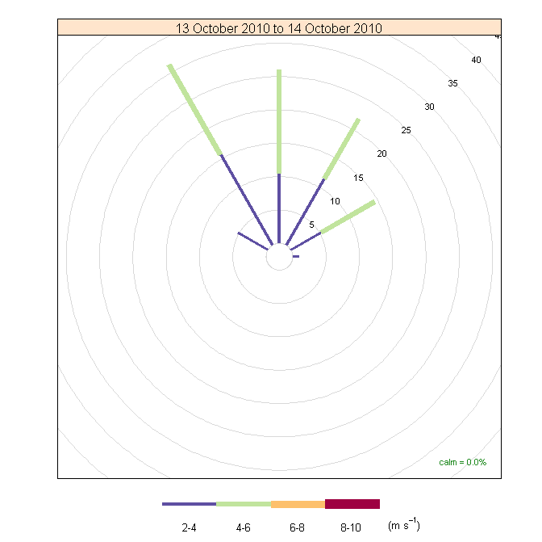

Episode Wind Range

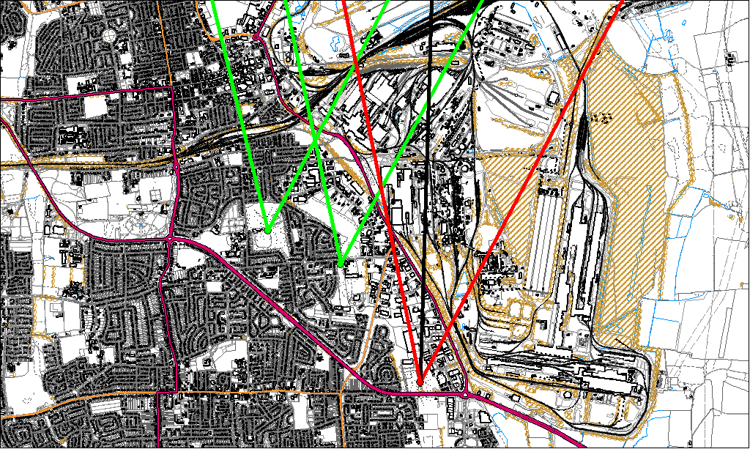

Potential Sources
The above map shows the Amvale Monitoring Station (indicated by the red lines) and the East Common Lane & Redbourne Sites (indicated by the green). The black line within the red shows the wind direction of the highest concentration during the period of focus.

As the TEOMs were not subject to the same elevated levels as the Osiris, it is likely that the source of the episode did not originate from within the wind sectors relevant to the TEOMs (green lines). By removing the area of wind sectors affecting both the Osiris & TEOM we can identify specific areas on site that may have been responsible for the exceedance.

The likely areas include;

- Civil & Marine
- Caparo
- Intermediate Site
- Blast Furnaces
- Sinter Plant

The black line indicates the highest measured concentration during this period. This runs through the Blast Furnace area. The overall pattern for the 12th & 13th are very similar. A sharp increase in concentrations after 19/20:00. Could the potential sources check for any differences in operations after these times.

